Homework Set #2

- (25 points) Rank the following 3 functions by order of asymptotic growth. That is, find an arrangement g₁(n), g₂(n), g₃(n) of the functions satisfying:

g₁(n) Ο( g₂(n) ), g₂(n) Ο( g₃(n) )

Justify your answer mathematically by showing values of c and n_{o} such that 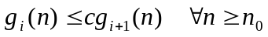

Functions:
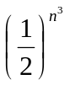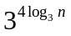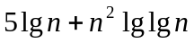

2. (25 points) Suppose that for 3 (possibly different) functions of n: f₁(n), f₂(n), f₃(n)
we know that:

i) f₁(n) Ω( (1/2)^{n}) ii) f₂(n) Θ( n ² lg n ) iii) f₃(n) Ο( lg³ n )

a) If statements (i)-(iii) are true, can we conclude that f₃(n) Ο( f₂(n) )? Why or why not?

b) If statements (i)-(iii) are true, can we conclude that f₂(n) Ω( f₁(n) )? Why or why not?

3. True or False (25 points).

  - 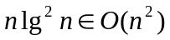 [ ]
  - 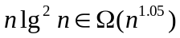 [ ]
  - 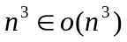 [ ]

  - The cost of the loop below is in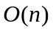 [ ]
for (i = 1; i <= n; i *= 2) { // n>=1
constant work;
}

  - The cost of the above loop is in 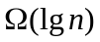 [ ]

4. (25 points) Pseudocode Analysis: For the pseudocode below for Mystery (n), find tight upper and lower bounds on its asymptotic worst-case running time f(n). That is, find g(n) such that f(n) Θ(g(n)). (Assume that n is a positive integer.) Justify your answer.

Mystery (n )
c 1
for i 1 to n
do for j i to n
do for k n down to 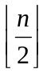 do c c + 1
print c

